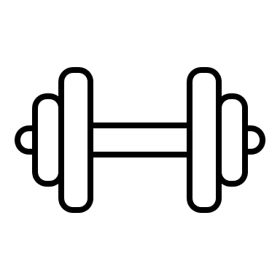
Arena fitness + fitness sisters spring challenge

~level one~ Week~ Date ~ .
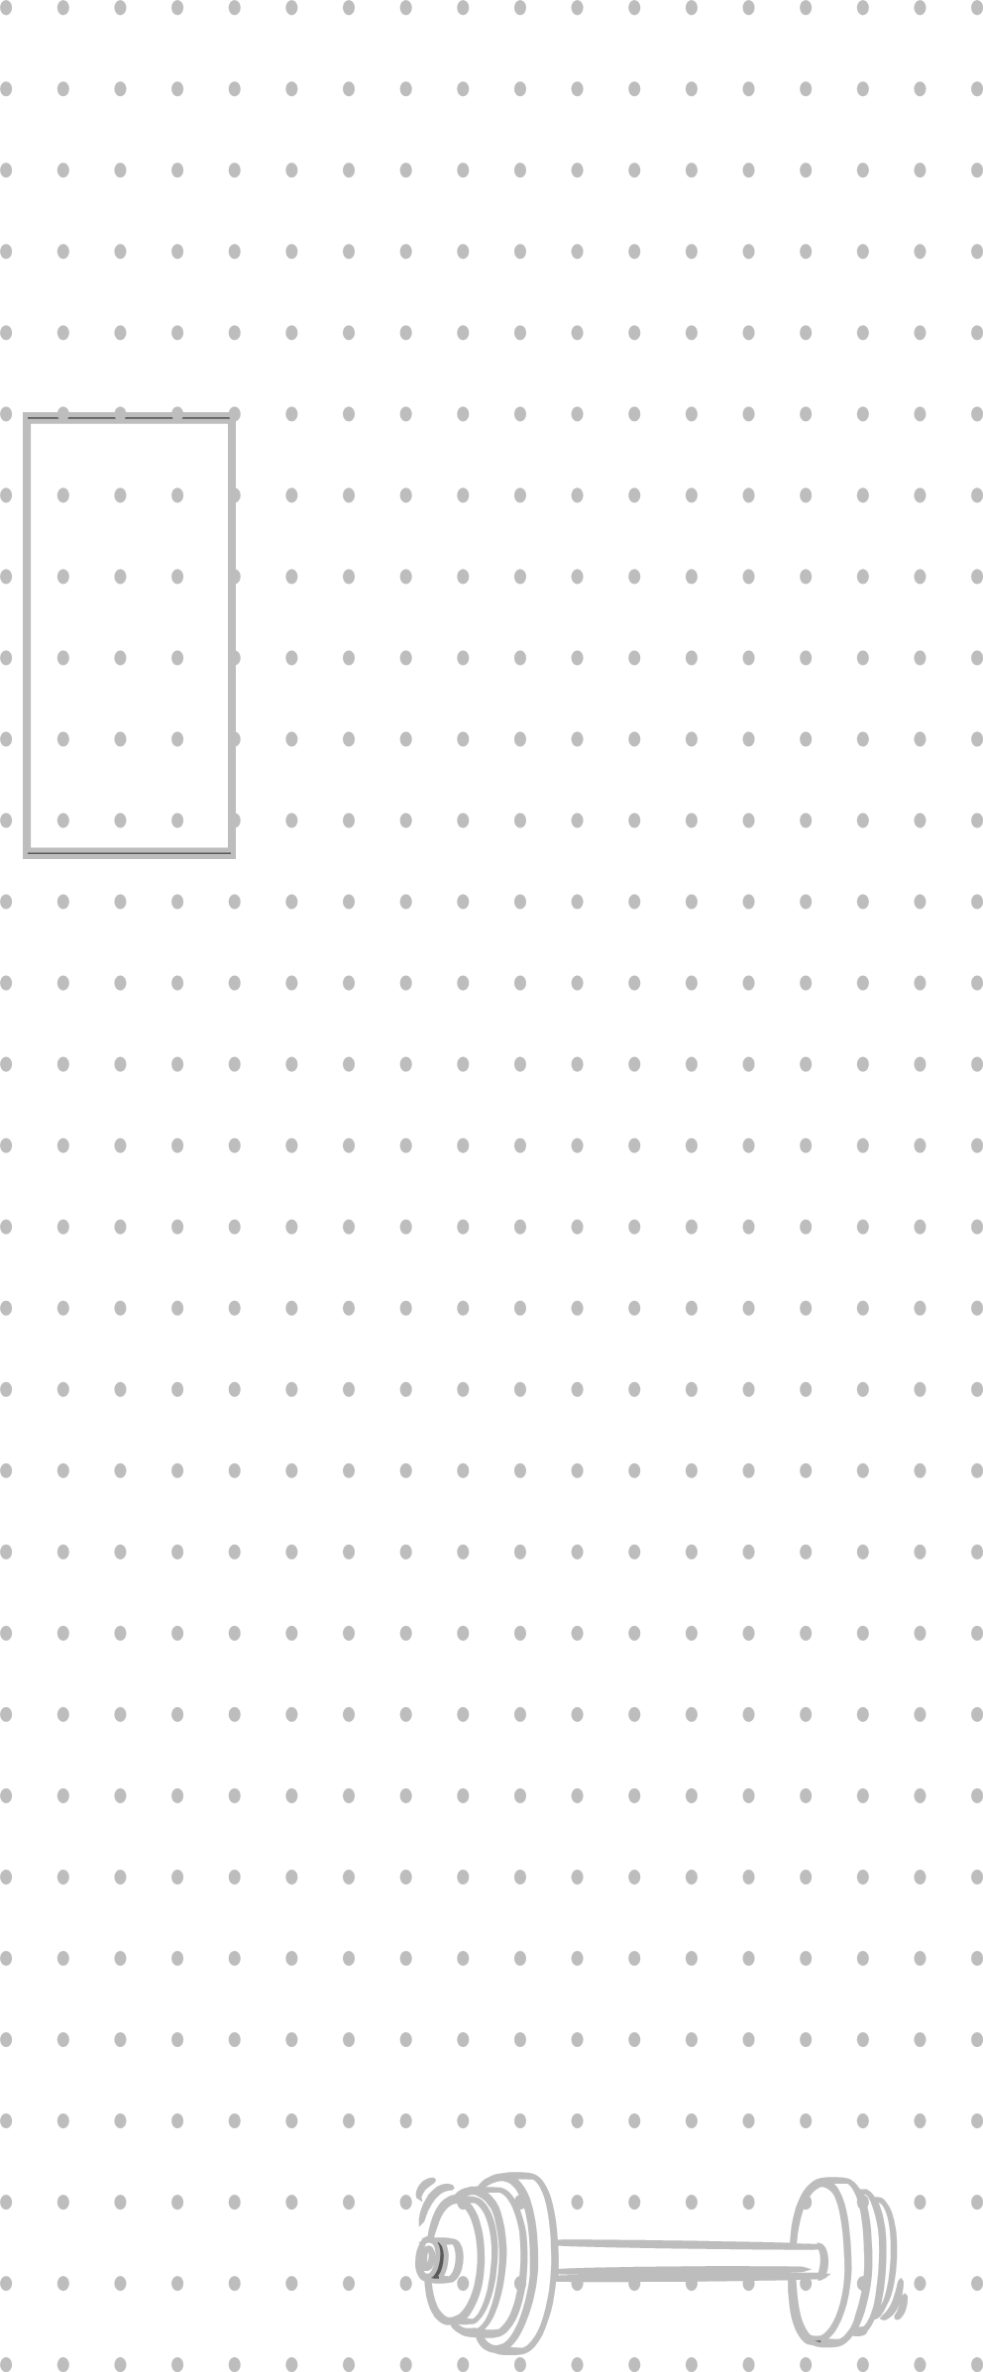
  Set one |  | Set two |  | Set three
  Light  weight | reps | Medium weight | reps | heavy weight | reps
  Set one |  | Set two |  | Set three
  Light  weight | reps | Medium weight | reps | heavy weight | reps
  Set one |  | Set two |  | Set three
  Light  weight | reps | Medium weight | reps | heavy weight | reps
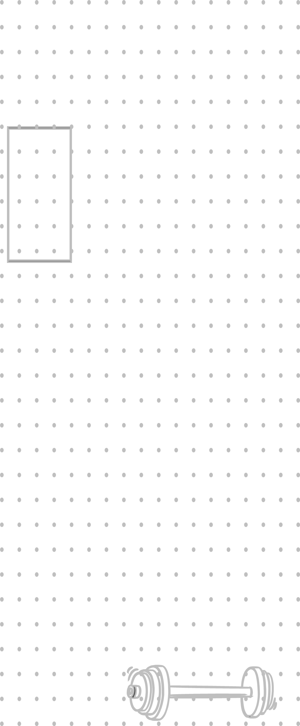
DAY ONE - Chest & shoulders .
Kneeling Push-Ups………………………………
Dumbbell Overhead Press………………
Supine dumbbell chest press…………
Bent over rear delt flies………………
DAY two- quads & hamstrings
Suitcase Squats……………………………………
Romanian dead lifts……….………………
Sumo squats……………………………….…………
Supine hamstring bridges………………

DAY three – arms .
Bicep hammer curls…......................………
Bent over tricep kickbacks…….………
Dumbbell Front raises………….…………
Dumbbell Side raises…………..……………

Arena fitness + fitness sisters spring challenge

~level one~ Week~ Date ~ .
Set one |  | Set two |  | Set three
Light  weight | reps | Medium weight | reps | heavy weight | reps
Set one |  | Set two |  | Set three
Light  weight | reps | Medium weight | reps | heavy weight | reps
Set one |  | Set two |  | Set three
Light  weight | reps | Medium weight | reps | heavy weight | reps

DAY four- upper & lower back
Standing band pull-aparts…...………
Bent over narrow rows…………………
Prone supermans…………………….………….
Bent over wide rows………...…………..…
DAY five – glutes .
Standing banded side leg lifts……
Standing banded glute kickbacks
Side lying banded clam shells…….
Supine banded hip thrusts……………..

DAY six – Core: abs & obliques
Suitcase Squats--………………………………
Romanian dead lifts……….………………
Sumo squats……………………………….…………
Supine hamstring bridges………………

Arena fitness + fitness sisters spring challenge

~level one~ Week~ Date ~ .
Set one |  | Set two |  | Set three
time | reps | time | reps | time | reps
time |  | time |  | time

DAY seven–cardio & flexibility
Side steps or grapevines w/ arms
no weight squats arms overhead
jogging in place……………………….………….
jumping jacks / power jacks.……..…
mountain climbers……………………….
Standing front kicks…………………….
----Complete cardio 3x then each stretch-----
Bring ear to shoulder………………
Standing straight leg toe touch…..
Standing back extension…………………..
Standing quad stretch……………………….
Standing side bend arm overhead
Butterfly hip stretch………………………..
Seated cross leg lumbar rotation
Cat-Cow w/ inhale-exhale…………...…

